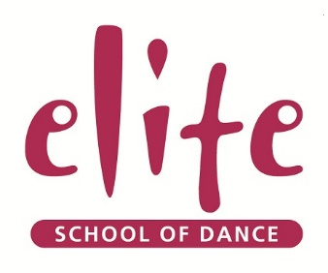
Elite Dance and Fitness Studios Ltd
The Square
Mercia Drive
Mynydd Isa
Flintshire
CH7 6UY

Dear Sirs
I am the Principal of Elite School of Dance in Mynydd Isa.
Earlier this year, we applied to be a part of Team Wales at the Dance World Cup in Germany, where 6000 dancers compete in different age categories and genres. We were thrilled to find out that our application had been successful and we are now going to be representing Wales, along with other dancing schools from throughout the country. We have been awarded 4 solos and 5 group dances at the finals in June, giving 30 dancers the opportunity of their lives. The finals will take place in Offenburg from Fri 24th June – Sat 1st July.
The event is a hugely prestigious occasion and showcases the very best dancing talent worldwide. Not only will it provide our dancers with an incredible opportunity to perform on the world’s biggest stage but it will provide so much more to their development as young people. Representing Team Wales will help them to gain confidence, develop a sense of team spirit with dancers who they may have previously competed against and will require discipline and maturity.
Our dancers are already fully on board with the project and have started to make fundraising plans to help support the trip. Ideas being planned include a ‘wear your pyjamas to dance’ week, a choreography competition that will be judged by an external adjudicator, bag packs at local Supermarkets and a charity gala dinner. Our dancers are feeling empowered to be taking control of their fundraising which is also a wonderful skill to be developing. To supplement this hard work, we are also seeking sponsorship from local companies who may be able to support our efforts in return for shared marketing opportunities. We have a very active social media presence and have already received press coverage in the Evening Leader and have planned future press releases. We also have access to over 1000 contacts from our dance and fitness business with whom we will share the details of all companies who are able to support our fundraising efforts, providing excellent PR for participating organisations.
Win or lose, these dancers have already achieved success on a fantastic scale. There is no higher accolade than to represent your country in your chosen sport or activity. Seeing them perform and do their best will be such a wonderful achievement and will make their families, their teachers and the whole of Team Wales very proud indeed.
If you’d like to look at more information on the Dance World Cup, full details can be found at
http://www.dwc-uk.com.
Yours faithfully
Emma Knox Jones
Mrs Emma Knox Jones
Principal – Elite School of Dance
Email: elite.reception@outlook.com
www.elitedanceandfitness.co.uk
Tel: 01352 879550

